First name : English test 3rd term 2018-2019
lire : écrire : parler : comprendre :
1. Listen and link.

Complete the sentence, and link.

Jane is in the……………………………- -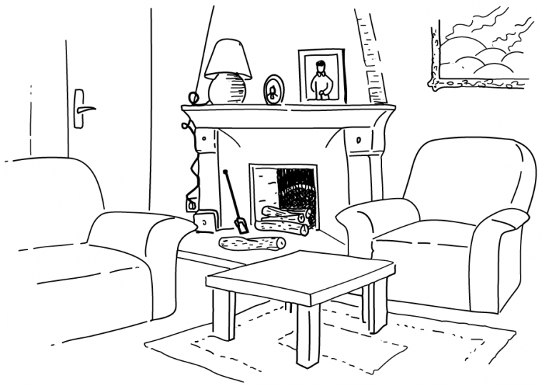
Oliver is in the…………………………- -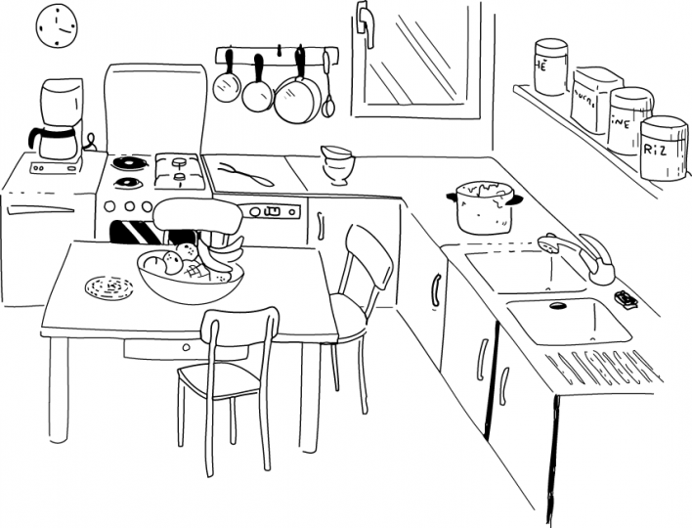
Andrew is in the ………………………- -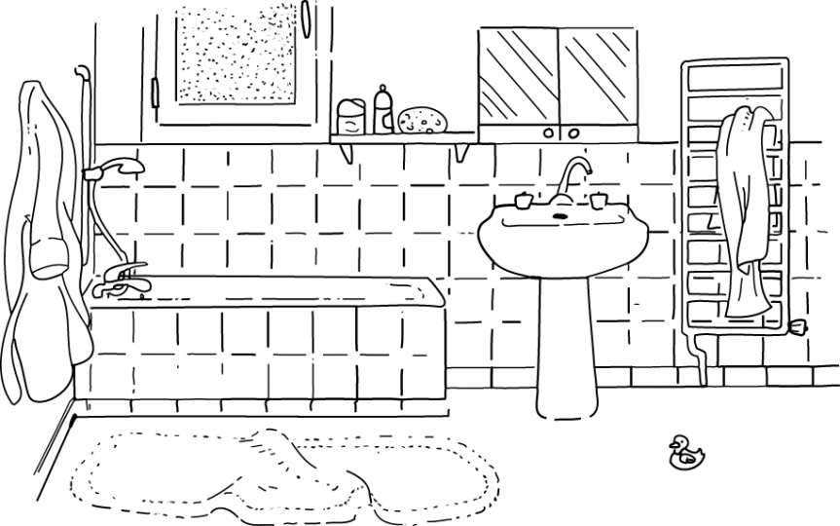
Cathy is in the…………………………- -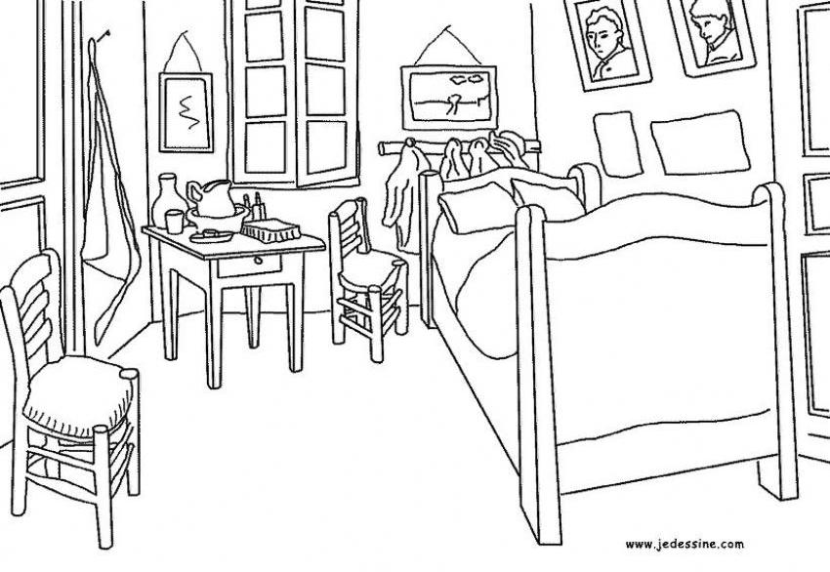

2. Read and draw where the mouse went.

“I entered the house using a hole in the ………………. Then, I went up into a bedroom. Then I went into the toilets, and the into the bathroom. A lady screamed, and I had to run up into the attic.”


