CM2
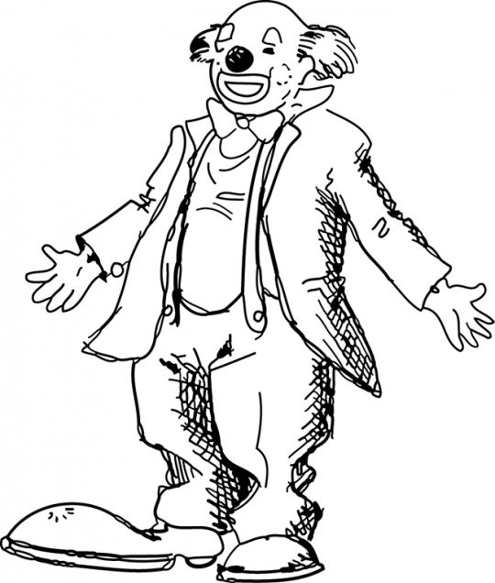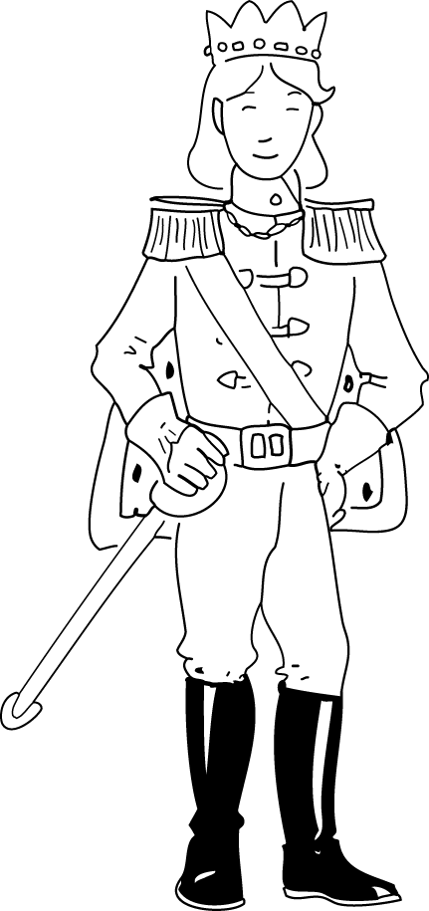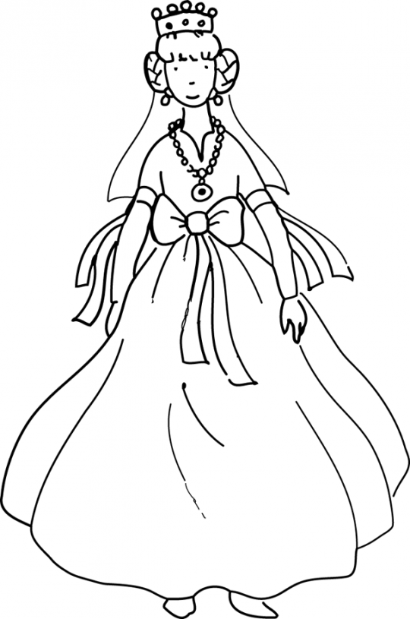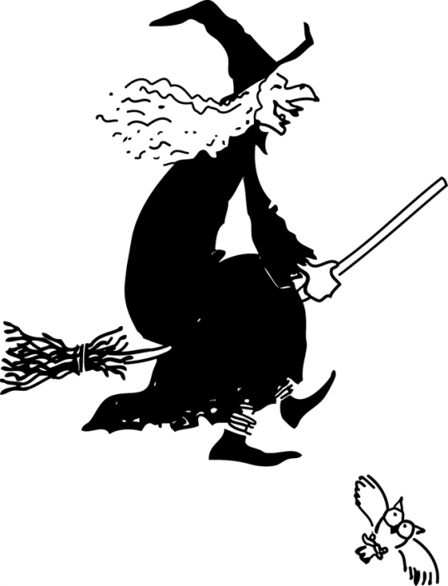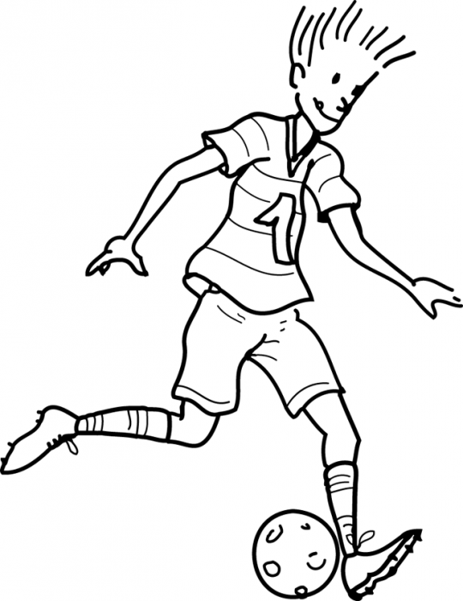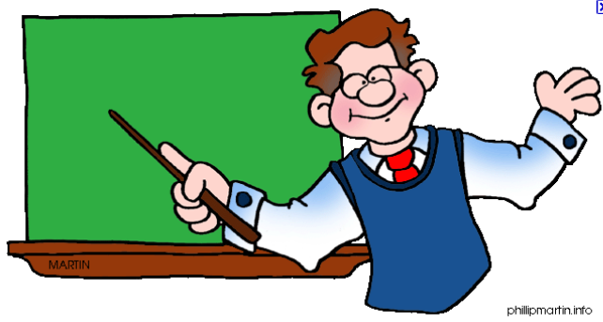
1 2 3 4 5 6
Complète les noms des personnages avec le bon numéro. Ensuite, relie les descriptions avec le bon personnage. Attention aux pièges, certaines descriptions ne correspondent à aucun personnage !
He’s wearing black boots, he’s got a sword and a crown on his head.

the princess (n°…)
the prince (n°…)
the football player (n°…)
the clown (n°…)
the teacher (n°…)
the witch (n°…)
She’s wearing black boots, she’s got a sword and a crown on her head.

He’s wearing big shoes, large trousers, a jacket and a bow-tie.

He’s wearing a black dress, a black hat and black shoes.

She’s wearing a black dress, a black hat and black shoes.

He’s wearing glasses, a shirt and a tie which one can’t entirely see because of his sleeveless pull-over.

He’s wearing shorts and a tee-shirt with the number one on it.

She’s wearing shorts and a tee-shirt with the number one on it.

She’s wearing a white dress, a necklace, and she’s got a crown on her head.

-----------------------------------------------------------------------------------------------------------------------------------------------
Now draw your own character and describe his/her clothes. (Maintenant, dessine ton propre personnage et décris ses vêtements.)

CM1
1 2 3 4 5 6
Complète les noms des personnages avec le bon numéro. Ensuite, relie les descriptions avec le bon personnage.
He’s wearing black boots, he’s got a sword and a crown on his head.

the princess (n°…)
the prince (n°…)
the football player (n°…)
the clown (n°…)
the teacher (n°6)
the witch (n°…)

He’s wearing big shoes, large trousers, a jacket and a bow-tie.

She’s wearing a black dress, a black hat and black shoes.

He’s wearing glasses, a shirt and a tie which one can’t entirely see because of his sleeveless pull-over.

He’s wearing shorts and a tee-shirt with the number one on it.

She’s wearing a white dress, a necklace, and she’s got a crown on her head.

-----------------------------------------------------------------------------------------------------------------------------------------------
Now draw your own character and describe his/her clothes. (Maintenant, dessine ton propre personnage et décris ses vêtements. Tu peux regarder dans ton cahier.)

CE2
the clown the prince the princess the witch the football player the teacher
Relie les descriptions lues par le maître avec le bon personnage.
He’s wearing black boots, he’s got a sword and a crown on his head.

the princess
the prince
the football player
the clown
the teacher
the witch

He’s wearing big shoes, large trousers, a jacket and a bow-tie.

She’s wearing a black dress, a black hat and black shoes.

He’s wearing glasses, a shirt and a tie which one can’t entirely see because of his sleeveless pull-over.

He’s wearing shorts and a tee-shirt with the number one on it.

She’s wearing a white dress, a necklace, and she’s got a crown on her head.

-----------------------------------------------------------------------------------------------------------------------------------------------
À l’aide de ton cahier, écris les noms de vêtements que tu vois sur ce dessin.


