"All Together Now" The Beatles - 1969
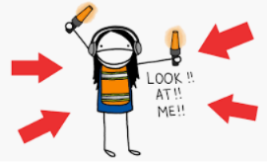
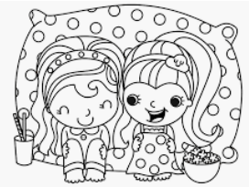
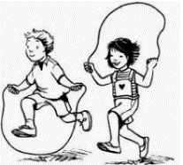
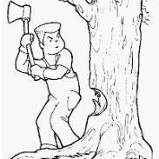
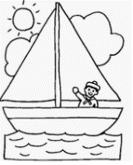
1, 2, 3, 4
Can I have a little more?
5, 6, 7, 8, 9, 10, I love you
A, B, C, D
Can I bring my friend to tea?
E, F, G, H, I, J, I love you
Sail the ship
Chop the tree
Skip the rope
Look at me
All together now
All together now
All together now
All together now
, , ,
Can I take my friend to bed?
, , , and , I love you
All together now
All together now
All together now
All together now
All together now
All together now
All together now
All together now
All together now
Sail the ship
Chop the tree
Skip the rope
Look at me
All together now
All together now
All together now
All together now
All together now
All together now
All together now
All together now
All together now
All together now
All together now
All together now

